QUESTION 1 - SMART CITY AIR QUALITY MONITORING

import numpy as np
import pandas as pd
import matplotlib.pyplot as plt
import seaborn as sns

# -----------------------------------------------------------
# Generate Sample Dataset
# -----------------------------------------------------------

np.random.seed(101)

n = 150

air = pd.DataFrame({
"Sensor_ID": np.arange(1, n+1),
"PM2.5": np.random.randint(20,220,n),
"NO2": np.random.randint(10,120,n),
"CO": np.round(np.random.uniform(0.3,5,n),2),
"Temperature": np.random.randint(18,42,n),
"Humidity": np.random.randint(35,95,n)
})

print(air.head())

# ===========================================================
# Visualization 1
# Sequential Color Palette
# ===========================================================

plt.figure(figsize=(10,6))

plt.scatter(
air["Temperature"],
air["PM2.5"],
c=air["PM2.5"],
cmap="Greens",
s=90
)

plt.colorbar(label="PM2.5")
plt.title("Sequential Palette - PM2.5 Pollution")
plt.xlabel("Temperature (°C)")
plt.ylabel("PM2.5")
plt.grid(True)

plt.show()

# ===========================================================
# Visualization 2
# Diverging Color Palette
# ===========================================================

plt.figure(figsize=(10,6))

plt.scatter(
air["Humidity"],
air["NO2"],
c=air["NO2"],
cmap="coolwarm",
s=90
)

plt.colorbar(label="NO2")
plt.title("Diverging Palette - NO2 Levels")
plt.xlabel("Humidity (%)")
plt.ylabel("NO2")
plt.grid(True)

plt.show()

# ===========================================================
# Create Pollution Categories
# ===========================================================

def pollution(pm):

if pm <= 50:
return "Good"

elif pm <= 100:
return "Moderate"

elif pm <= 150:
return "Poor"

else:
return "Very Poor"

air["Category"] = air["PM2.5"].apply(pollution)

# ===========================================================
# Visualization 3
# Qualitative Palette
# ===========================================================

plt.figure(figsize=(10,6))

sns.scatterplot(
data=air,
x="Temperature",
y="Humidity",
hue="Category",
palette="Set2",
s=100
)

plt.title("Pollution Categories")
plt.xlabel("Temperature")
plt.ylabel("Humidity")

plt.show()

# ===========================================================
# Visualization 4
# Heatmap
# ===========================================================

plt.figure(figsize=(8,6))

corr = air[["PM2.5","NO2","CO","Temperature","Humidity"]].corr()

sns.heatmap(
corr,
annot=True,
cmap="RdYlGn",
linewidths=0.5
)

plt.title("Correlation Heatmap")

plt.show()

# ===========================================================
# Visualization 5
# Histogram
# ===========================================================

plt.figure(figsize=(8,5))

sns.histplot(
air["PM2.5"],
bins=20,
color="orange",
kde=True
)

plt.title("Distribution of PM2.5")

plt.xlabel("PM2.5")

plt.show()

# ===========================================================
# Visualization 6
# Box Plot
# ===========================================================

plt.figure(figsize=(8,6))

sns.boxplot(
x="Category",
y="PM2.5",
data=air,
palette="Set3"
)

plt.title("PM2.5 by Pollution Category")

plt.show()

# ===========================================================
# Visualization 7
# Pair Plot
# ===========================================================

sns.pairplot(
air,
vars=["PM2.5","NO2","CO","Temperature","Humidity"],
hue="Category",
palette="Set1"
)

plt.show()

# ===========================================================
# Conclusion
# ===========================================================

print("\nSequential Palette (Greens): Best for showing pollution intensity.")
print("Diverging Palette (Coolwarm): Best for comparing low and high pollution.")
print("Qualitative Palette (Set2): Best for identifying pollution categories.")
print("Heatmap: Shows correlation among variables.")
print("Histogram: Displays PM2.5 distribution.")
print("Boxplot: Compares pollution categories.")
print("Pairplot: Shows relationships among all variables.")

OUTPUT:
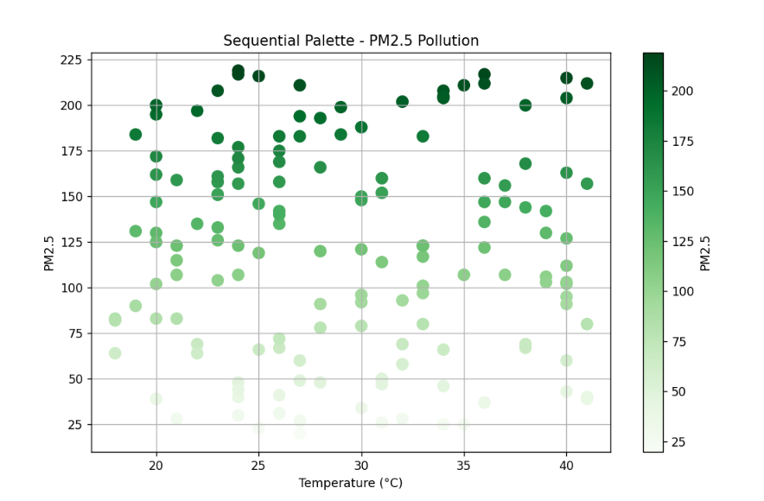

QUESTION 2 - EARTHQUAKE RISK ANALYSIS

import numpy as np
import pandas as pd
import matplotlib.pyplot as plt
import seaborn as sns

# -----------------------------------------------------------
# Generate Sample Earthquake Dataset
# -----------------------------------------------------------

np.random.seed(100)

n = 1000

earthquake = pd.DataFrame({
"Magnitude": np.round(np.random.uniform(0.5, 9.5, n), 1),
"Depth": np.random.randint(1, 701, n),
"Latitude": np.round(np.random.uniform(-90, 90, n), 2),
"Longitude": np.round(np.random.uniform(-180, 180, n), 2),
"Aftershocks": np.random.randint(0, 250, n)
})

print(earthquake.head())

# ===========================================================
# Visualization 1
# Linear Scatter Plot
# ===========================================================

plt.figure(figsize=(10,6))

plt.scatter(
earthquake["Magnitude"],
earthquake["Depth"],
c=earthquake["Aftershocks"],
cmap="viridis",
s=50
)

plt.colorbar(label="Aftershocks")
plt.title("Earthquake Magnitude vs Depth (Linear Scale)")
plt.xlabel("Magnitude")
plt.ylabel("Depth (km)")
plt.grid(True)

plt.show()

# ===========================================================
# Visualization 2
# Logarithmic Scatter Plot
# ===========================================================

plt.figure(figsize=(10,6))

plt.scatter(
earthquake["Magnitude"],
earthquake["Depth"],
c=earthquake["Aftershocks"],
cmap="plasma",
s=50
)

plt.yscale("log")

plt.colorbar(label="Aftershocks")

plt.title("Earthquake Magnitude vs Depth (Log Scale)")
plt.xlabel("Magnitude")
plt.ylabel("Depth (km - Log Scale)")
plt.grid(True)

plt.show()

# ===========================================================
# Visualization 3
# Histogram - Magnitude
# ===========================================================

plt.figure(figsize=(8,5))

sns.histplot(
earthquake["Magnitude"],
bins=20,
color="steelblue",
kde=True
)

plt.title("Distribution of Earthquake Magnitude")
plt.xlabel("Magnitude")
plt.ylabel("Frequency")

plt.show()

# ===========================================================
# Visualization 4
# Histogram - Depth (Log Scale)
# ===========================================================

plt.figure(figsize=(8,5))

plt.hist(
earthquake["Depth"],
bins=30,
color="orange"
)

plt.yscale("log")

plt.title("Depth Distribution (Log Scale)")
plt.xlabel("Depth (km)")
plt.ylabel("Frequency (Log Scale)")

plt.show()

# ===========================================================
# Visualization 5
# Box Plot
# ===========================================================

plt.figure(figsize=(8,5))

sns.boxplot(
y=earthquake["Magnitude"],
color="lightgreen"
)

plt.title("Earthquake Magnitude Box Plot")

plt.show()

# ===========================================================
# Visualization 6
# Correlation Heatmap
# ===========================================================

plt.figure(figsize=(8,6))

corr = earthquake.corr(numeric_only=True)

sns.heatmap(
corr,
annot=True,
cmap="coolwarm",
linewidths=0.5
)

plt.title("Correlation Matrix")

plt.show()

# ===========================================================
# Visualization 7
# Pair Plot
# ===========================================================

sns.pairplot(
earthquake[["Magnitude",
"Depth",
"Aftershocks"]]
)

plt.show()

# ===========================================================
# Conclusion
# ===========================================================

print("\nInterpretation:")
print("1. Linear scale displays the actual depth values.")
print("2. Log scale compresses large depth values and highlights smaller earthquakes.")
print("3. Scatter plots reveal the relationship between magnitude and depth.")
print("4. Heatmap shows correlation among earthquake variables.")
print("5. Histogram displays the frequency distribution.")
print("6. Box plot helps identify outliers.")
print("7. Pair plot shows relationships among numerical features.")

OUTPUT:
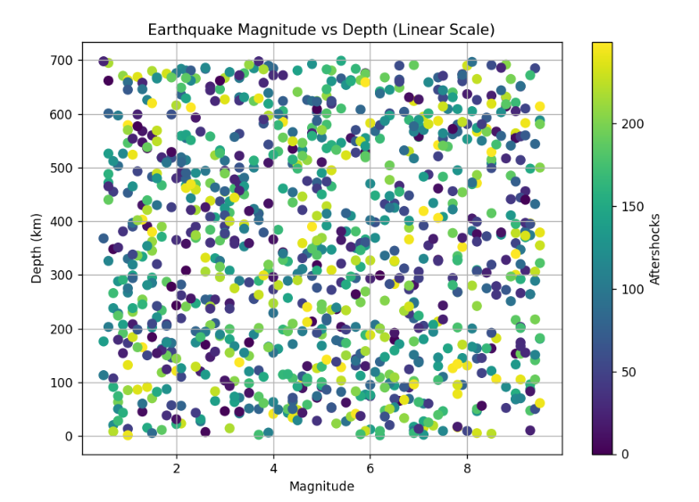

QUESTION 3 - WIND DIRECTION ANALYSIS

import numpy as np
import pandas as pd
import matplotlib.pyplot as plt
import seaborn as sns

# -----------------------------------------------------------
# Generate Sample Dataset
# -----------------------------------------------------------

np.random.seed(123)

n = 365

wind = pd.DataFrame({
"Day": np.arange(1, n + 1),
"WindSpeed": np.random.uniform(5, 40, n),
"WindDirection": np.random.uniform(0, 360, n)
})

# -----------------------------------------------------------
# Create Seasons
# -----------------------------------------------------------

wind["Season"] = pd.cut(
wind["Day"],
bins=[0, 90, 181, 273, 365],
labels=["Winter", "Summer", "Monsoon", "Autumn"]
)

print(wind.head())

# ===========================================================
# Visualization 1
# Wind Speed Throughout the Year
# ===========================================================

plt.figure(figsize=(12,6))

plt.scatter(
wind["Day"],
wind["WindSpeed"],
c=wind["WindSpeed"],
cmap="viridis",
s=70
)

plt.colorbar(label="Wind Speed (km/h)")
plt.title("Wind Speed Throughout the Year")
plt.xlabel("Day")
plt.ylabel("Wind Speed (km/h)")
plt.grid(True)

plt.show()

# ===========================================================
# Visualization 2
# Wind Direction vs Speed
# ===========================================================

plt.figure(figsize=(12,6))

plt.scatter(
wind["WindDirection"],
wind["WindSpeed"],
c=wind["WindSpeed"],
cmap="plasma",
s=70
)

plt.colorbar(label="Wind Speed")
plt.title("Wind Direction vs Wind Speed")
plt.xlabel("Wind Direction (Degrees)")
plt.ylabel("Wind Speed (km/h)")
plt.grid(True)

plt.show()

# ===========================================================
# Visualization 3
# Polar Plot (Wind Rose)
# ===========================================================

theta = np.deg2rad(wind["WindDirection"])

fig = plt.figure(figsize=(8,8))

ax = fig.add_subplot(111, projection="polar")

points = ax.scatter(
theta,
wind["WindSpeed"],
c=wind["WindSpeed"],
cmap="coolwarm",
s=40
)

plt.colorbar(points, label="Wind Speed (km/h)")

ax.set_title("Wind Rose")

plt.show()

# ===========================================================
# Visualization 4
# Average Wind Speed by Season
# ===========================================================

season_avg = wind.groupby("Season", observed=False)["WindSpeed"].mean().reset_index()

plt.figure(figsize=(8,5))

sns.barplot(
data=season_avg,
x="Season",
y="WindSpeed",
hue="Season",
palette="Set2",
legend=False
)

plt.title("Average Wind Speed by Season")
plt.xlabel("Season")
plt.ylabel("Average Wind Speed (km/h)")

plt.show()

# ===========================================================
# Visualization 5
# Wind Speed Histogram
# ===========================================================

plt.figure(figsize=(8,5))

sns.histplot(
wind["WindSpeed"],
bins=20,
color="green",
kde=True
)

plt.title("Wind Speed Distribution")
plt.xlabel("Wind Speed (km/h)")
plt.ylabel("Frequency")

plt.show()

# ===========================================================
# Visualization 6
# Box Plot
# ===========================================================

plt.figure(figsize=(8,5))

sns.boxplot(
data=wind,
x="Season",
y="WindSpeed",
hue="Season",
palette="Set3",
legend=False
)

plt.title("Wind Speed by Season")

plt.show()

# ===========================================================
# Visualization 7
# Correlation Heatmap
# ===========================================================

plt.figure(figsize=(6,5))

corr = wind[["WindSpeed", "WindDirection"]].corr(numeric_only=True)

sns.heatmap(
corr,
annot=True,
cmap="RdYlBu",
linewidths=0.5
)

plt.title("Correlation Heatmap")

plt.show()

# ===========================================================
# Summary
# ===========================================================

print("\n========= INTERPRETATION =========")
print("1. Cartesian plot shows wind speed variation throughout the year.")
print("2. Scatter plot shows the relationship between wind direction and wind speed.")
print("3. Polar plot (Wind Rose) identifies dominant wind directions.")
print("4. Bar chart compares seasonal average wind speeds.")
print("5. Histogram shows wind speed distribution.")
print("6. Box plot compares wind speed variability among seasons.")
print("7. Heatmap shows the correlation between wind speed and direction.")
print("\nConclusion: Polar (Wind Rose) visualization is the best choice for airport operations because it clearly shows the dominant wind directions used for runway planning and flight safety.")

OUTPUT:
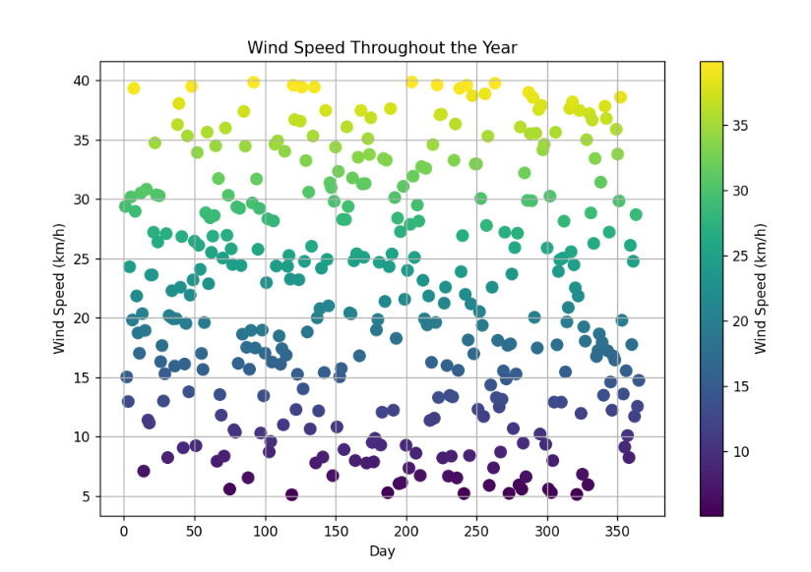

Question 4 - Hospital Patient Monitoring Dashboard

import numpy as np
import pandas as pd
import matplotlib.pyplot as plt
import seaborn as sns

# -----------------------------------------------------------
# Generate Sample ICU Dataset
# -----------------------------------------------------------

np.random.seed(123)

minutes = np.arange(1, 61)

icu = pd.DataFrame({
"Minute": minutes,
"HeartRate": np.random.randint(55, 130, 60),
"Oxygen": np.random.randint(85, 100, 60),
"BloodPressure": np.random.randint(80, 170, 60),
"Respiration": np.random.randint(10, 30, 60),
"Temperature": np.round(np.random.uniform(35.5, 39.5, 60),1)
})

# -----------------------------------------------------------
# Heart Rate Status
# -----------------------------------------------------------

icu["HR_Status"] = np.where(
(icu["HeartRate"]>=60) & (icu["HeartRate"]<=100),
"Normal",
"Abnormal"
)

# -----------------------------------------------------------
# Oxygen Status
# -----------------------------------------------------------

icu["O2_Status"] = np.where(
icu["Oxygen"]>=95,
"Normal",
"Critical"
)

# -----------------------------------------------------------
# Blood Pressure Status
# -----------------------------------------------------------

icu["BP_Status"] = np.where(
(icu["BloodPressure"]>=90) &
(icu["BloodPressure"]<=140),
"Normal",
"High/Low"
)

# -----------------------------------------------------------
# Respiration Status
# -----------------------------------------------------------

icu["Resp_Status"] = np.where(
(icu["Respiration"]>=12) &
(icu["Respiration"]<=20),
"Normal",
"Abnormal"
)

# -----------------------------------------------------------
# Temperature Status
# -----------------------------------------------------------

icu["Temp_Status"] = np.where(
(icu["Temperature"]>=36) &
(icu["Temperature"]<=37.5),
"Normal",
"Abnormal"
)

print(icu.head())

# ===========================================================
# Plot 1 - Heart Rate
# ===========================================================

plt.figure(figsize=(12,5))

colors = icu["HR_Status"].map({
"Normal":"green",
"Abnormal":"red"
})

plt.scatter(
icu["Minute"],
icu["HeartRate"],
c=colors,
s=80
)

plt.plot(icu["Minute"], icu["HeartRate"], color="gray")

plt.axhline(60,color="blue",linestyle="--")
plt.axhline(100,color="blue",linestyle="--")

plt.title("Heart Rate Monitoring")
plt.xlabel("Minute")
plt.ylabel("Heart Rate (BPM)")
plt.grid(True)

plt.show()

# ===========================================================
# Plot 2 - Oxygen Saturation
# ===========================================================

plt.figure(figsize=(12,5))

colors = icu["O2_Status"].map({
"Normal":"green",
"Critical":"red"
})

plt.scatter(
icu["Minute"],
icu["Oxygen"],
c=colors,
s=80
)

plt.plot(icu["Minute"], icu["Oxygen"], color="gray")

plt.axhline(95,color="blue",linestyle="--")

plt.title("Oxygen Saturation")
plt.xlabel("Minute")
plt.ylabel("SpO2 (%)")
plt.grid(True)

plt.show()

# ===========================================================
# Plot 3 - Blood Pressure
# ===========================================================

plt.figure(figsize=(12,5))

colors = icu["BP_Status"].map({
"Normal":"green",
"High/Low":"red"
})

plt.scatter(
icu["Minute"],
icu["BloodPressure"],
c=colors,
s=80
)

plt.plot(icu["Minute"], icu["BloodPressure"], color="gray")

plt.axhline(90,color="blue",linestyle="--")
plt.axhline(140,color="blue",linestyle="--")

plt.title("Blood Pressure")
plt.xlabel("Minute")
plt.ylabel("Blood Pressure (mmHg)")
plt.grid(True)

plt.show()

# ===========================================================
# Plot 4 - Respiration Rate
# ===========================================================

plt.figure(figsize=(12,5))

colors = icu["Resp_Status"].map({
"Normal":"green",
"Abnormal":"red"
})

plt.scatter(
icu["Minute"],
icu["Respiration"],
c=colors,
s=80
)

plt.plot(icu["Minute"], icu["Respiration"], color="gray")

plt.axhline(12,color="blue",linestyle="--")
plt.axhline(20,color="blue",linestyle="--")

plt.title("Respiration Rate")
plt.xlabel("Minute")
plt.ylabel("Breaths/Minute")
plt.grid(True)

plt.show()

# ===========================================================
# Plot 5 - Temperature
# ===========================================================

plt.figure(figsize=(12,5))

colors = icu["Temp_Status"].map({
"Normal":"green",
"Abnormal":"red"
})

plt.scatter(
icu["Minute"],
icu["Temperature"],
c=colors,
s=80
)

plt.plot(icu["Minute"], icu["Temperature"], color="gray")

plt.axhline(36,color="blue",linestyle="--")
plt.axhline(37.5,color="blue",linestyle="--")

plt.title("Body Temperature")
plt.xlabel("Minute")
plt.ylabel("Temperature (°C)")
plt.grid(True)

plt.show()

# ===========================================================
# Correlation Heatmap
# ===========================================================

plt.figure(figsize=(8,6))

corr = icu[[
"HeartRate",
"Oxygen",
"BloodPressure",
"Respiration",
"Temperature"
]].corr()

sns.heatmap(
corr,
annot=True,
cmap="coolwarm",
linewidths=0.5
)

plt.title("Patient Health Parameter Correlation")

plt.show()

# ===========================================================
# Summary
# ===========================================================

print("\n========== ICU DASHBOARD SUMMARY ==========")
print("Heart Rate Normal : 60 - 100 BPM")
print("Oxygen Normal : >= 95%")
print("Blood Pressure : 90 - 140 mmHg")
print("Respiration : 12 - 20 breaths/min")
print("Temperature : 36 - 37.5 °C")

print("\nGreen = Normal")
print("Red = Critical / Abnormal")
print("Blue Dashed Lines = Threshold Values")
print("\nThis dashboard quickly highlights abnormal patient conditions for doctors.")

OUTPUT:
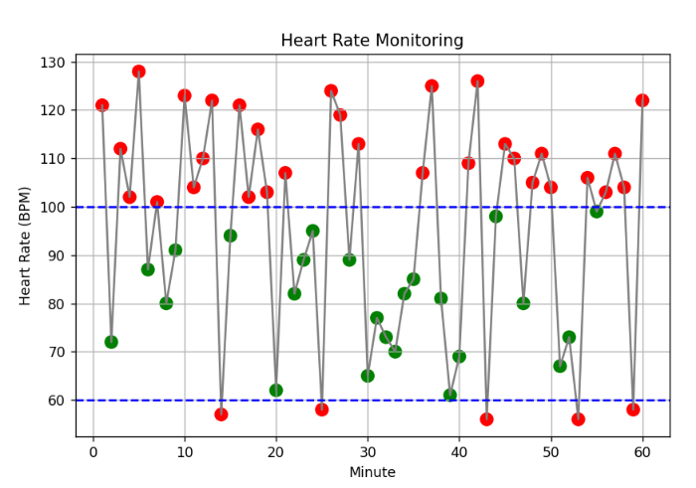

QUESTION 5 - GLOBAL CLIMATE CHANGE STUDY

import numpy as np
import pandas as pd
import matplotlib.pyplot as plt
import seaborn as sns

# -----------------------------------------------------------
# Generate Sample Dataset
# -----------------------------------------------------------

np.random.seed(123)

countries = [f"Country_{i}" for i in range(1,181)]
years = np.arange(1980,2026)

climate = pd.DataFrame(
[(country, year) for country in countries for year in years],
columns=["Country","Year"]
)

# Temperature anomaly (-3°C to +3°C)

climate["Anomaly"] = np.round(
np.random.normal(0,1.2,len(climate)),
2
)

print(climate.head())

# -----------------------------------------------------------
# Pivot Table
# -----------------------------------------------------------

heatmap_data = climate.pivot(
index="Country",
columns="Year",
values="Anomaly"
)

# ===========================================================
# Heatmap 1
# Coolwarm Palette
# ===========================================================

plt.figure(figsize=(16,12))

sns.heatmap(
heatmap_data,
cmap="coolwarm",
center=0,
cbar_kws={"label":"Temperature Anomaly (°C)"}
)

plt.title("Heatmap using Coolwarm Palette")

plt.xlabel("Year")
plt.ylabel("Country")

plt.show()

# ===========================================================
# Heatmap 2
# RdBu Palette
# ===========================================================

plt.figure(figsize=(16,12))

sns.heatmap(
heatmap_data,
cmap="RdBu_r",
center=0,
cbar_kws={"label":"Temperature Anomaly (°C)"}
)

plt.title("Heatmap using RdBu Palette")

plt.xlabel("Year")
plt.ylabel("Country")

plt.show()

# ===========================================================
# Heatmap 3
# Spectral Palette
# ===========================================================

plt.figure(figsize=(16,12))

sns.heatmap(
heatmap_data,
cmap="Spectral_r",
center=0,
cbar_kws={"label":"Temperature Anomaly (°C)"}
)

plt.title("Heatmap using Spectral Palette")

plt.xlabel("Year")
plt.ylabel("Country")

plt.show()

# ===========================================================
# Line Chart
# Average Temperature Anomaly by Year
# ===========================================================

avg_year = climate.groupby("Year")["Anomaly"].mean()

plt.figure(figsize=(14,6))

plt.plot(
avg_year.index,
avg_year.values,
color="red",
linewidth=2
)

plt.axhline(0,color="black",linestyle="--")

plt.title("Average Global Temperature Anomaly (1980-2025)")
plt.xlabel("Year")
plt.ylabel("Average Temperature Anomaly (°C)")
plt.grid(True)

plt.show()

# ===========================================================
# Histogram
# ===========================================================

plt.figure(figsize=(10,5))

sns.histplot(
climate["Anomaly"],
bins=30,
color="purple",
kde=True
)

plt.title("Distribution of Temperature Anomalies")

plt.xlabel("Temperature Anomaly (°C)")

plt.show()

# ===========================================================
# Box Plot
# ===========================================================

plt.figure(figsize=(8,5))

sns.boxplot(
y=climate["Anomaly"],
color="skyblue"
)

plt.title("Box Plot of Temperature Anomalies")

plt.ylabel("Temperature Anomaly (°C)")

plt.show()

# ===========================================================
# Summary
# ===========================================================

print("\n========== ANALYSIS ==========")

print("1. Coolwarm palette clearly separates positive and negative anomalies.")
print("2. RdBu palette provides strong contrast between warming and cooling.")
print("3. Spectral palette displays gradual variation effectively.")
print("4. Line chart shows long-term climate trend.")
print("5. Histogram displays anomaly distribution.")
print("6. Box plot highlights spread and outliers.")

print("\nAccessibility Recommendation:")
print("- Use color-blind friendly palettes.")
print("- Include legends and labels.")
print("- Avoid relying only on red-green colors.")
print("- RdBu and Coolwarm are recommended for climate analysis.")

OUTPUT:
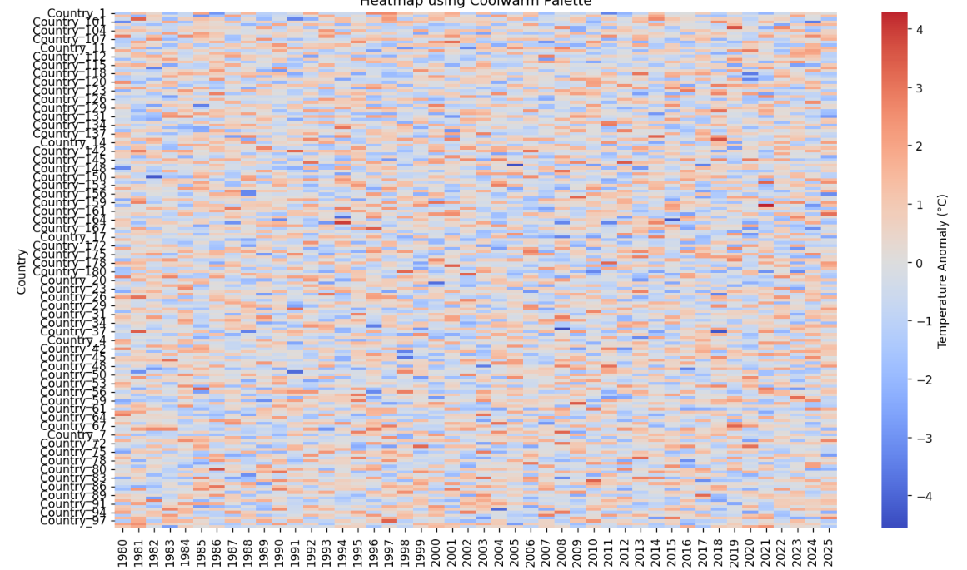

QUESTION 6 - E-COMMERCE SALES ANALYTICS

import numpy as np
import pandas as pd
import matplotlib.pyplot as plt
import seaborn as sns

# -----------------------------------------------------------
# Generate Sample Dataset
# -----------------------------------------------------------

np.random.seed(123)

categories = [f"Category_{i}" for i in range(1, 51)]
regions = [f"Region_{i}" for i in range(1, 31)]

sales = pd.DataFrame(
[(category, region) for category in categories for region in regions],
columns=["Category", "Region"]
)

sales["Sales"] = np.random.randint(1000, 100000, len(sales))

sales["Profit"] = np.random.randint(100, 30000, len(sales))

print(sales.head())

# ===========================================================
# Visualization 1
# Heatmap
# ===========================================================

pivot_sales = sales.pivot_table(
values="Sales",
index="Category",
columns="Region",
aggfunc="sum"
)

plt.figure(figsize=(15,12))

sns.heatmap(
pivot_sales,
cmap="YlOrRd",
linewidths=0.3,
cbar_kws={"label":"Sales"}
)

plt.title("Sales Heatmap")
plt.xlabel("Region")
plt.ylabel("Product Category")

plt.show()

# ===========================================================
# Visualization 2
# Bar Chart
# ===========================================================

category_sales = sales.groupby("Category", as_index=False)["Sales"].sum()

category_sales = category_sales.sort_values(
by="Sales",
ascending=False
)

plt.figure(figsize=(14,10))

sns.barplot(
data=category_sales,
x="Sales",
y="Category",
hue="Category",
palette="tab20",
legend=False
)

plt.title("Total Sales by Product Category")
plt.xlabel("Sales")
plt.ylabel("Category")

plt.show()

# ===========================================================
# Visualization 3
# Scatter Plot
# ===========================================================

plt.figure(figsize=(12,7))

scatter = plt.scatter(
sales["Sales"],
sales["Profit"],
c=sales["Sales"],
cmap="viridis",
s=70
)

plt.colorbar(scatter, label="Sales")

plt.title("Sales vs Profit")
plt.xlabel("Sales")
plt.ylabel("Profit")

plt.grid(True)

plt.show()

# ===========================================================
# Visualization 4
# Bubble Chart
# ===========================================================

plt.figure(figsize=(12,7))

bubble = plt.scatter(
sales["Sales"],
sales["Profit"],
s=sales["Profit"] / 100,
c=sales["Sales"],
cmap="plasma",
alpha=0.7
)

plt.colorbar(bubble, label="Sales")

plt.title("Bubble Chart: Sales vs Profit")
plt.xlabel("Sales")
plt.ylabel("Profit")

plt.grid(True)

plt.show()

# ===========================================================
# Visualization 5
# Pie Chart
# ===========================================================

top10 = category_sales.head(10)

plt.figure(figsize=(9,9))

plt.pie(
top10["Sales"],
labels=top10["Category"],
autopct="%1.1f%%",
startangle=90
)

plt.title("Top 10 Product Categories")

plt.show()

# ===========================================================
# Visualization 6
# Box Plot
# ===========================================================

plt.figure(figsize=(8,6))

sns.boxplot(
y=sales["Sales"],
color="skyblue"
)

plt.title("Sales Distribution")

plt.show()

# ===========================================================
# Visualization 7
# Histogram
# ===========================================================

plt.figure(figsize=(10,6))

sns.histplot(
sales["Sales"],
bins=30,
color="green",
kde=True
)

plt.title("Distribution of Sales")

plt.xlabel("Sales")

plt.show()

# ===========================================================
# Visualization 8
# Correlation Heatmap
# ===========================================================

plt.figure(figsize=(6,5))

corr = sales[["Sales", "Profit"]].corr()

sns.heatmap(
corr,
annot=True,
cmap="coolwarm",
linewidths=0.5
)

plt.title("Correlation Heatmap")

plt.show()

# ===========================================================
# Summary
# ===========================================================

print("\n========== ANALYSIS ==========")

print("1. Heatmap identifies high-sales regions.")
print("2. Bar chart compares total sales across product categories.")
print("3. Scatter plot shows the relationship between Sales and Profit.")
print("4. Bubble chart represents Sales using both size and color.")
print("5. Pie chart displays the contribution of top-selling categories.")
print("6. Histogram shows the sales distribution.")
print("7. Box plot identifies outliers.")
print("8. Correlation heatmap shows the relationship between Sales and Profit.")

print("\nChallenges of Color Encoding:")
print("- Qualitative colors distinguish categories.")
print("- Quantitative colors represent numerical sales values.")
print("- Too many colors may confuse users.")
print("- Use gradients for numerical values and distinct colors for categories.")

OUTPUT:
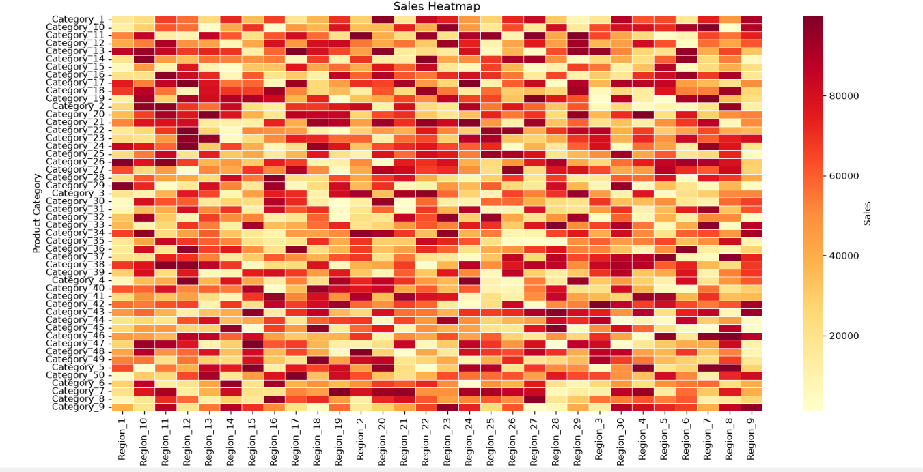

QUESTION 7 - SOCIAL MEDIA SENTIMENT ANALYSIS

import numpy as np
import pandas as pd
import matplotlib.pyplot as plt
import seaborn as sns

# -----------------------------------------------------------
# Generate Sample Dataset
# -----------------------------------------------------------

np.random.seed(123)

platforms = ["Facebook", "Instagram", "Twitter", "LinkedIn", "YouTube"]

n = 500

social = pd.DataFrame({
"Platform": np.random.choice(platforms, n),
"SentimentScore": np.round(np.random.uniform(-1, 1, n), 2)
})

# -----------------------------------------------------------
# Classify Sentiment
# -----------------------------------------------------------

def sentiment(score):
if score > 0.2:
return "Positive"
elif score < -0.2:
return "Negative"
else:
return "Neutral"

social["Sentiment"] = social["SentimentScore"].apply(sentiment)

print(social.head())

# ===========================================================
# Plot 1 - Count Plot
# ===========================================================

plt.figure(figsize=(8,5))

sns.countplot(
data=social,
x="Sentiment",
hue="Sentiment",
palette="Set2",
legend=False
)

plt.title("Sentiment Distribution")
plt.xlabel("Sentiment")
plt.ylabel("Count")

plt.show()

# ===========================================================
# Plot 2 - Sentiment by Platform
# ===========================================================

plt.figure(figsize=(10,6))

sns.countplot(
data=social,
x="Platform",
hue="Sentiment",
palette="Set1"
)

plt.title("Sentiment across Social Media Platforms")
plt.xlabel("Platform")
plt.ylabel("Number of Posts")

plt.show()

# ===========================================================
# Plot 3 - Box Plot
# ===========================================================

plt.figure(figsize=(10,6))

sns.boxplot(
data=social,
x="Platform",
y="SentimentScore",
hue="Platform",
palette="Pastel1",
legend=False
)

plt.title("Sentiment Score Distribution by Platform")

plt.show()

# ===========================================================
# Plot 4 - Histogram
# ===========================================================

plt.figure(figsize=(10,5))

sns.histplot(
social["SentimentScore"],
bins=25,
kde=True,
color="blue"
)

plt.title("Histogram of Sentiment Scores")
plt.xlabel("Sentiment Score")

plt.show()

# ===========================================================
# Plot 5 - Pie Chart
# ===========================================================

counts = social["Sentiment"].value_counts()

plt.figure(figsize=(7,7))

plt.pie(
counts,
labels=counts.index,
autopct="%1.1f%%",
startangle=90
)

plt.title("Overall Sentiment Distribution")

plt.show()

# ===========================================================
# Plot 6 - Average Sentiment by Platform
# ===========================================================

avg = social.groupby("Platform", as_index=False)["SentimentScore"].mean()

plt.figure(figsize=(10,6))

sns.barplot(
data=avg,
x="Platform",
y="SentimentScore",
hue="Platform",
palette="viridis",
legend=False
)

plt.title("Average Sentiment Score by Platform")
plt.xlabel("Platform")
plt.ylabel("Average Sentiment Score")

plt.show()

# ===========================================================
# Plot 7 - Heatmap
# ===========================================================

pivot = pd.crosstab(
social["Platform"],
social["Sentiment"]
)

plt.figure(figsize=(8,5))

sns.heatmap(
pivot,
annot=True,
cmap="YlGnBu",
linewidths=0.5
)

plt.title("Platform vs Sentiment Heatmap")

plt.show()

# ===========================================================
# Summary
# ===========================================================

print("\n========== ANALYSIS ==========")
print("1. Count plot shows overall sentiment distribution.")
print("2. Grouped bar chart compares sentiments across platforms.")
print("3. Box plot displays sentiment score variation.")
print("4. Histogram shows score distribution.")
print("5. Pie chart shows percentage of sentiments.")
print("6. Bar chart compares average sentiment score.")
print("7. Heatmap shows sentiment frequency by platform.")

print("\nPalette Comparison:")
print("Set1 : Best for Positive, Neutral and Negative categories.")
print("Set2 : Soft colors for presentation.")
print("Viridis: Best for numerical sentiment scores.")
print("YlGnBu : Excellent for heatmaps.")

OUTPUT:
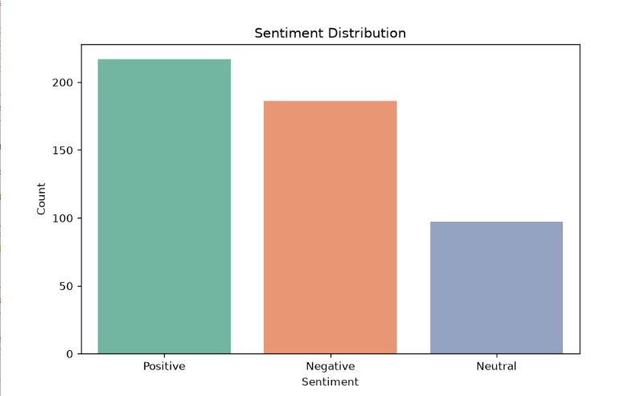
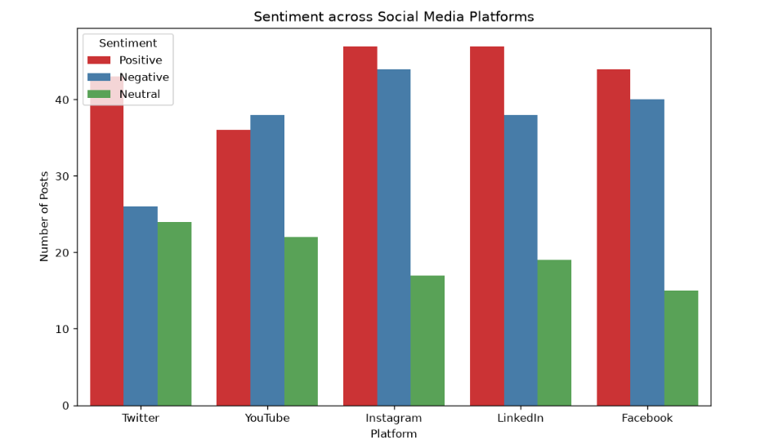
QUESTION 8 - GLOBAL AIR QUALITY INDEX (AQI) ANALYSIS

import numpy as np
import pandas as pd
import matplotlib.pyplot as plt
import seaborn as sns

# -----------------------------------------------------------
# Generate Sample Dataset
# -----------------------------------------------------------

np.random.seed(123)

cities = [
"Delhi","Mumbai","Chennai","Bangalore","Hyderabad",
"Kolkata","Pune","Jaipur","Ahmedabad","Lucknow",
"Surat","Bhopal","Patna","Nagpur","Coimbatore",
"Visakhapatnam","Kochi","Madurai","Mysore","Goa"
]

aqi = pd.DataFrame({
"City": cities,
"AQI": np.random.randint(30, 450, len(cities))
})

# -----------------------------------------------------------
# AQI Category
# -----------------------------------------------------------

def classify(aqi_value):
if aqi_value <= 50:
return "Good"
elif aqi_value <= 100:
return "Moderate"
elif aqi_value <= 200:
return "Poor"
elif aqi_value <= 300:
return "Very Poor"
else:
return "Severe"

aqi["Category"] = aqi["AQI"].apply(classify)

print(aqi)

# ===========================================================
# Plot 1 - Bar Chart
# ===========================================================

plt.figure(figsize=(12,6))

sns.barplot(
data=aqi,
x="City",
y="AQI",
hue="Category",
palette="Set2"
)

plt.xticks(rotation=45)
plt.title("AQI of Different Cities")
plt.xlabel("City")
plt.ylabel("AQI")

plt.show()

# ===========================================================
# Plot 2 - Scatter Plot
# ===========================================================

plt.figure(figsize=(12,6))

sns.scatterplot(
data=aqi,
x="City",
y="AQI",
hue="Category",
palette="Set1",
s=150
)

plt.xticks(rotation=45)
plt.title("AQI Scatter Plot")

plt.show()

# ===========================================================
# Plot 3 - Heatmap
# ===========================================================

heat = aqi.set_index("City")[["AQI"]]

plt.figure(figsize=(5,8))

sns.heatmap(
heat,
annot=True,
cmap="RdYlGn_r",
linewidths=0.5
)

plt.title("AQI Heatmap")

plt.show()

# ===========================================================
# Plot 4 - Histogram
# ===========================================================

plt.figure(figsize=(8,5))

sns.histplot(
aqi["AQI"],
bins=10,
kde=True,
color="purple"
)

plt.title("AQI Distribution")
plt.xlabel("AQI")

plt.show()

# ===========================================================
# Plot 5 - Pie Chart
# ===========================================================

counts = aqi["Category"].value_counts()

plt.figure(figsize=(7,7))

plt.pie(
counts,
labels=counts.index,
autopct="%1.1f%%",
startangle=90
)

plt.title("AQI Categories")

plt.show()

# ===========================================================
# Plot 6 - Box Plot
# ===========================================================

plt.figure(figsize=(6,5))

sns.boxplot(
y=aqi["AQI"],
color="lightgreen"
)

plt.title("AQI Box Plot")

plt.show()

# ===========================================================
# Plot 7 - Violin Plot
# ===========================================================

plt.figure(figsize=(7,5))

sns.violinplot(
data=aqi,
y="AQI",
color="skyblue"
)

plt.title("AQI Violin Plot")

plt.show()

# ===========================================================
# Summary
# ===========================================================

print("\n========== ANALYSIS ==========")
print("1. Bar chart compares AQI of cities.")
print("2. Scatter plot highlights AQI categories.")
print("3. Heatmap visualizes AQI intensity.")
print("4. Histogram shows AQI distribution.")
print("5. Pie chart shows percentage of AQI categories.")
print("6. Box plot identifies spread and outliers.")
print("7. Violin plot displays AQI distribution shape.")

print("\nPalette Comparison:")
print("Set1 : Best for AQI categories.")
print("Set2 : Good for presentations.")
print("RdYlGn_r : Best for AQI heatmaps.")
print("\nConclusion: RdYlGn_r is the best palette because")
print("green indicates good air quality while red indicates severe pollution.")

OUTPUT:
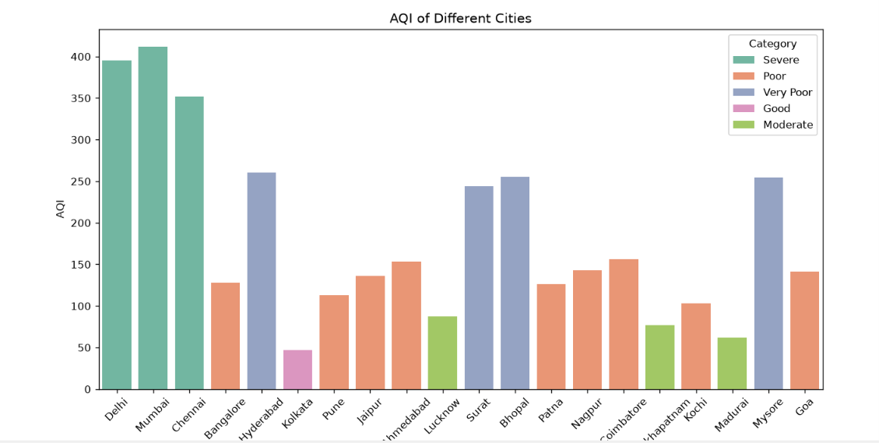

QUESTION 9 - STUDENT ACADEMIC PERFORMANCE DASHBOARD

import numpy as np
import pandas as pd
import matplotlib.pyplot as plt
import seaborn as sns

# -----------------------------------------------------------
# Generate Sample Dataset
# -----------------------------------------------------------

np.random.seed(123)

n = 100

students = pd.DataFrame({
"StudentID": [f"S{i}" for i in range(1, n+1)],
"StudyHours": np.random.randint(1, 8, n),
"Attendance": np.random.randint(60, 101, n),
"Marks": np.random.randint(35, 101, n)
})

# -----------------------------------------------------------
# Performance Category
# -----------------------------------------------------------

def performance(mark):
if mark >= 85:
return "Excellent"
elif mark >= 70:
return "Good"
elif mark >= 50:
return "Average"
else:
return "Poor"

students["Performance"] = students["Marks"].apply(performance)

print(students.head())

# ===========================================================
# Plot 1 - Scatter Plot
# ===========================================================

plt.figure(figsize=(10,6))

sns.scatterplot(
data=students,
x="StudyHours",
y="Marks",
hue="Performance",
palette="Set1",
s=120
)

plt.title("Study Hours vs Marks")
plt.xlabel("Study Hours")
plt.ylabel("Marks")
plt.grid(True)

plt.show()

# ===========================================================
# Plot 2 - Attendance vs Marks
# ===========================================================

plt.figure(figsize=(10,6))

sns.scatterplot(
data=students,
x="Attendance",
y="Marks",
hue="Performance",
palette="viridis",
s=120
)

plt.title("Attendance vs Marks")
plt.xlabel("Attendance (%)")
plt.ylabel("Marks")
plt.grid(True)

plt.show()

# ===========================================================
# Plot 3 - Performance Count
# ===========================================================

plt.figure(figsize=(8,5))

sns.countplot(
data=students,
x="Performance",
hue="Performance",
palette="Set2",
legend=False
)

plt.title("Student Performance Categories")

plt.show()

# ===========================================================
# Plot 4 - Average Marks
# ===========================================================

avg_marks = students.groupby(
"Performance",
as_index=False
)["Marks"].mean()

plt.figure(figsize=(8,5))

sns.barplot(
data=avg_marks,
x="Performance",
y="Marks",
hue="Performance",
palette="coolwarm",
legend=False
)

plt.title("Average Marks by Performance")

plt.show()

# ===========================================================
# Plot 5 - Histogram
# ===========================================================

plt.figure(figsize=(8,5))

sns.histplot(
students["Marks"],
bins=15,
kde=True,
color="green"
)

plt.title("Distribution of Marks")
plt.xlabel("Marks")

plt.show()

# ===========================================================
# Plot 6 - Box Plot
# ===========================================================

plt.figure(figsize=(8,5))

sns.boxplot(
data=students,
x="Performance",
y="Marks",
hue="Performance",
palette="Pastel1",
legend=False
)

plt.title("Marks by Performance")

plt.show()

# ===========================================================
# Plot 7 - Heatmap
# ===========================================================

corr = students[
["StudyHours", "Attendance", "Marks"]
].corr()

plt.figure(figsize=(6,5))

sns.heatmap(
corr,
annot=True,
cmap="YlGnBu",
linewidths=0.5
)

plt.title("Correlation Heatmap")

plt.show()

# ===========================================================
# Plot 8 - Pie Chart
# ===========================================================

performance_count = students["Performance"].value_counts()

plt.figure(figsize=(7,7))

plt.pie(
performance_count,
labels=performance_count.index,
autopct="%1.1f%%",
startangle=90
)

plt.title("Performance Distribution")

plt.show()

# ===========================================================
# Summary
# ===========================================================

print("\n========== ANALYSIS ==========")
print("1. Scatter plot shows Study Hours vs Marks.")
print("2. Scatter plot shows Attendance vs Marks.")
print("3. Count plot displays student performance levels.")
print("4. Bar chart compares average marks.")
print("5. Histogram shows marks distribution.")
print("6. Box plot identifies variation and outliers.")
print("7. Heatmap shows correlation among variables.")
print("8. Pie chart displays performance percentage.")

print("\nConclusion:")
print("Students with higher attendance and more study hours")
print("generally achieve higher marks.")

OUTPUT:
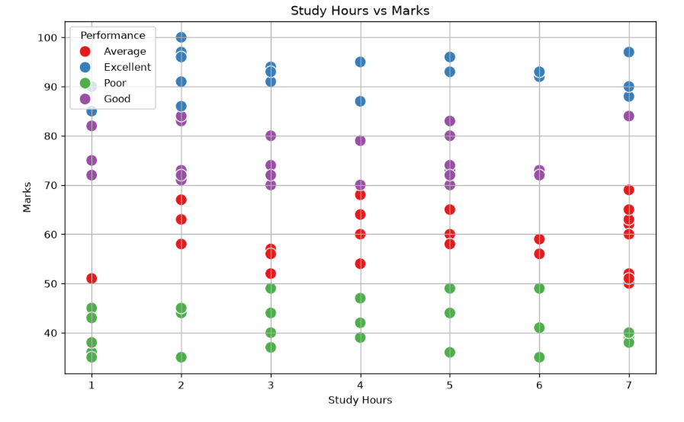

QUESTION 10 - COVID-19 VACCINATION CAMPAIGN DASHBOARD

import numpy as np
import pandas as pd
import matplotlib.pyplot as plt
import seaborn as sns

# -----------------------------------------------------------
# Generate Sample Dataset
# -----------------------------------------------------------

np.random.seed(123)

districts = [
"Chennai","Coimbatore","Madurai","Salem","Trichy",
"Erode","Vellore","Tirunelveli","Thanjavur","Thoothukudi"
]

age_groups = ["18-30","31-45","46-60","60+"]

vaccines = ["Covishield","Covaxin","Sputnik V"]

rows = []

for district in districts:
for age in age_groups:
for vaccine in vaccines:
rows.append([
district,
age,
vaccine,
np.random.randint(5000,50000)
])

vaccination = pd.DataFrame(
rows,
columns=[
"District",
"AgeGroup",
"Vaccine",
"Vaccinated"
]
)

print(vaccination.head())

# ===========================================================
# Dashboard Version 1
# Qualitative Palette
# ===========================================================

plt.figure(figsize=(12,6))

sns.barplot(
data=vaccination,
x="District",
y="Vaccinated",
hue="Vaccine",
palette="Set2"
)

plt.xticks(rotation=45)

plt.title("Vaccination by District and Vaccine Type")
plt.xlabel("District")
plt.ylabel("Vaccinated People")

plt.show()

# ===========================================================
# Dashboard Version 2
# Color-Blind Friendly Palette
# ===========================================================

pivot = vaccination.pivot_table(
values="Vaccinated",
index="District",
columns="AgeGroup",
aggfunc="sum"
)

plt.figure(figsize=(8,6))

sns.heatmap(
pivot,
annot=True,
cmap="cividis",
linewidths=0.5,
fmt=".0f"
)

plt.title("Vaccination Rate by District and Age Group")

plt.show()

# ===========================================================
# Age Group Distribution
# ===========================================================

plt.figure(figsize=(8,5))

sns.barplot(
data=vaccination,
x="AgeGroup",
y="Vaccinated",
hue="AgeGroup",
palette="viridis",
legend=False
)

plt.title("Vaccination by Age Group")

plt.show()

# ===========================================================
# Vaccine Distribution
# ===========================================================

vaccine_total = vaccination.groupby(
"Vaccine",
as_index=False
)["Vaccinated"].sum()

plt.figure(figsize=(7,7))

plt.pie(
vaccine_total["Vaccinated"],
labels=vaccine_total["Vaccine"],
autopct="%1.1f%%",
startangle=90
)

plt.title("Overall Vaccine Distribution")

plt.show()

# ===========================================================
# District-wise Distribution
# ===========================================================

district_total = vaccination.groupby(
"District",
as_index=False
)["Vaccinated"].sum()

plt.figure(figsize=(12,6))

sns.lineplot(
data=district_total,
x="District",
y="Vaccinated",
marker="o"
)

plt.xticks(rotation=45)

plt.title("Total Vaccinations by District")

plt.show()

# ===========================================================
# Box Plot
# ===========================================================

plt.figure(figsize=(8,5))

sns.boxplot(
data=vaccination,
x="Vaccine",
y="Vaccinated",
hue="Vaccine",
palette="Pastel1",
legend=False
)

plt.title("Vaccination Distribution by Vaccine")

plt.show()

# ===========================================================
# Histogram
# ===========================================================

plt.figure(figsize=(8,5))

sns.histplot(
vaccination["Vaccinated"],
bins=20,
kde=True,
color="green"
)

plt.title("Distribution of Vaccination Counts")

plt.xlabel("Vaccinated")

plt.show()

# ===========================================================
# Correlation Heatmap
# ===========================================================

numeric = vaccination[["Vaccinated"]]

plt.figure(figsize=(4,4))

sns.heatmap(
numeric.corr(),
annot=True,
cmap="coolwarm"
)

plt.title("Correlation Heatmap")

plt.show()

# ===========================================================
# Summary
# ===========================================================

print("\n========== ANALYSIS ==========")

print("Version 1:")
print("- Uses Set2 palette.")
print("- Suitable for policymakers.")
print("- Clearly distinguishes vaccine types.")

print("\nVersion 2:")
print("- Uses Cividis palette.")
print("- Color-blind friendly.")
print("- Easy to identify vaccination intensity.")

print("\nAccessibility:")
print("- Avoid red-green combinations.")
print("- Use labels along with colors.")
print("- Cividis and Viridis are suitable for users with color vision deficiencies.")

print("\nConclusion:")
print("Dashboard 1 is best for comparing vaccine types.")
print("Dashboard 2 is best for identifying vaccination coverage across districts.")

OUTPUT:
